~Asia-Japan-Mirror-Edo-Cranes and Turtle

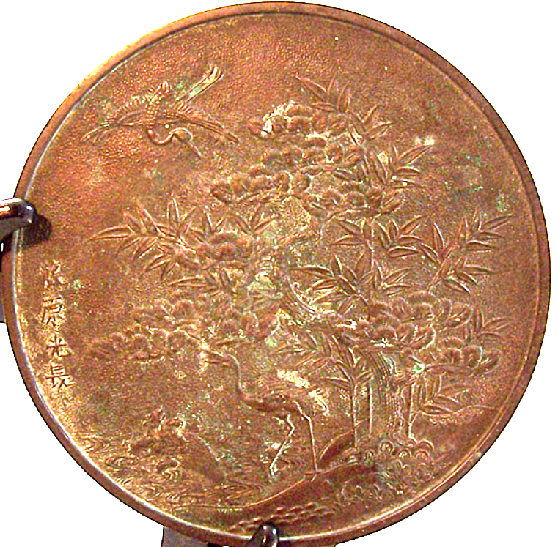

# Late 1800's Edo to Meiji Bronze Large Handled Dressing Mirror

